Morphology and Morphosyntax

MORPHOLOGY
It studies the processes of word formation and their internal structure. It has to do with semantics. It can change the meaning: possible, im-possible
Words connected together like sad, sad-ness or short, short-ness. So, the root carries lexical meaning. In Italian roots generally are not words (cant-are, cant-iamo), instead in English root are words (sing, sing-s).
Base form or Lemma is a word (basic form the word), this is the form you consult in a dictionary and from which Lexemes (morphological modifications of the word) depend. Ex: Lemma 🡪 to sing, Lexeme 🡪 sings
The link between the form of a word and the object it denoted is arbitrary. If the link is arbitrary then it must be learned (apple, apfel, apple).

Canto, canti, centavo, cantabile, cantante, canzone, canzoncina all these forms have the same Lemma. So, it is cheaper to store roots than learn all the each one by each one and apply the common rule.
A rule can be applied to several roots play, played, playable or sing, sang, cantabile, singer…
Roots and Rules: Cant – o (verb, 1p), i (verb, 2p), a (verb, 3p), av, bil, nt

Another argument for storing root and rules regards inventing new words from know words as stritolacarta, sbriciolabiscotti. We know the mechanisms to form complex words starting from simple words, even form words that do not exist but are permissible.
- aio: person who sell the object denoted by the noun 🡪 in Italian
- er/or: person who does the action referred to by the verb like produced, director, baker, dolliter (invented word) 🡪 in English

Morpheme: minimal unit with a meaning. There are simple words like lettera that can be decomposed:
- Letter-e = root + inflectional morpheme
- Letter-s = root + inflectional morpheme
- Null morphemes: in English could be 0 morphemes

Inflectional Morphemes:
- Letter-a/-e: consists of 2 morphems (gender and number)
- Letter -0/-s: consists of 1 morphem (only number, gender is the root)
- Portavo: consists of 4 morphems (port-a-v-o, where a is the thematic vowel for 1 conjugation, v is referred to the past, o regards 1st person singular)
- Walked: consists of 1 morpheme (ed referred to the past)
🡪 such morphemes are called inflectional: they are applied to a root (noun) and modified its number information (Moreover, they don’t change the meaning or the syntactic category of the word to which they apply).
In Italian and English they are at the end of the world.
With nouns, verbs we can find: Number (cas-a, cas-e), Gender (cas-a, alber-o), Case (ros-a/am), Person (speaker I, addressee YOU) 🡪 depending on the language.
Gender, Number and Person are very important for anaphora resolution. Ex: Il bambino si affaciò alla finestra, vide Maria e la salutò.
Pronouns are useful to connect part of the text 🡪 they keep coherence. Ex: the aunt promised Mario and Pietro to take them to the sea and told them that she would warn them before.
Gender (Nouns):
- Nouns are assigned to the masculine, feminine class in Italian
- in German we also have the neuter gender
- Wambayin (Australian Language) has four classes.
Definiteness is also important about inflectional morphology:
- Ex: The plane is coming (definitive)
- Ex: They said that a certain man had died (indefinitive)
Verb (In Italian and English they are at the end of the word) 🡪 Inflectional morphology on the verb can allow to identify the referent.
- Tense: cucino/cucinavo, In german past tense is compatible with adverbs staying for past, present, future (hans ha scritto la lettera ieri, Hans hat gestern den Brief geschriben)
- Aspect: expresses how an action, event, or state, as denoted by a verb extends over time (
- Mood/Modality: ways of expressing relationships to truth (subjunctive, hypothethical). There are different ways of expressing modality (modal verbs: can, shall, must…)
- Evidentiality: it is important for sentiment analysis and machine translation (Ex: I have evidence that Ahmet has arrived /speaker has direct evidence – I have been told that Ahmed has arrived/speaker has indirect evidence). It is not encoded in Italian or English but in languages like Turkish.
- Honorofic: these morphemese mark the social status of the person involved in the conversation (for instance, in Italian we can say Venga or Vieni). It is also useful for anaphora resolution to understand who is the referent.
- Negation: in Italian or English negation is an independent word or it is attached to something (Ex: John did not eat pizza – John didn’t eat pizza) 🡪 but in these languages exist in isolation, in other languages like Siberian, it is an inflectional morphemes and it is expressed as an affix to the verb.

The inflectional morphemes seen are Bound Morphemes (do not exist in isolation).
Free morphemes in Italian/English are: articles, auxiliaries, preposition.
Allomorphs: the form of a morpheme can be sensitive to its phonological context (context means the preceding sound). The same morphemes can be realized differently.
- Italian: the morpheme that expresses MASC.SING.DEF on articles is realized as Il, lo, the other that expresses MASC.PLUR.DEF is realized as i, gli
- English: changes depdendent….
Another way that morpheme can change according to the context is called Vowel Harmony (the vowel changes as a function of the vowel of the root)

Morph and Morpheme
- Italian: casa is form by two morphemes (-a is called the morph 🡪 the concrete realization)
- English: speak is forb by two morphemes (-s is called the morph)

What is the nature of inflectional rules? Agreement: It depends on the type of inflection:
- Una ragazza istruita – delle ragazze istruite
The morphology of the noun, on the one hand, and of the article and the adjective on the other, seem to be governed by different principles. Intuitively we make the adjective and article agree with noun and not vice versa. Similarly in sentences:
- This cat runs, these cats run-0 (the verb run agrees
- Il gatto corre, i gatti corrono

The inflection of the noun depends on a free choice of who speaks; if the speaker decides to identify a plurality of individuals using a certain noun, he will use the plural form of that noun.
On the contrary, the inflectional value of the adjective, the article, and the verb does not depend on a free choice of the speaker but on grammatical principles.

Morphologize grammatical categories that the grammar requires to be mandatorily expressed:
- Ragazzo/Ragazzi
- Boy/Boys

Exercise:
- He speaks (
- He walked (
- Maria parlò
- I bambini francesi giocano con i gatti rossi (i, -i, -i, -ano, -i, -i indicate MASC.PLUR)

Derivational Morphemes: modified the meaning and the syntactic category of the word to which they apply. We may obtain new words from other words. Derivational morphemes can be of 3 types:
- Prefixes: [Ex-console] 🡪 these are before the word and do not change the category of the base form.
- Infixes: [cant-icchi-are] 🡪 these are inside the word.
- Suffixed: [Libr-aio] 🡪 these are after the word and can change the category of the base form.
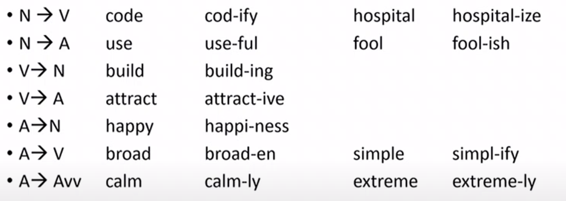
Some changes induced by suffixation:

Suffixation is more spread in languages compared to Prefixation. However, a NLP system does a morphological analysis and looks for suffixes only, has problems in some languages.
Meaning of some derivational affixes:
- able 🡪 doable, understandable 🡪 meaning: can be verb
- al 🡪 refusal, recital 🡪 meaning: the act of verb
- er 🡪 teacher, producer 🡪 meaning: person that verb
- ize 🡪 modernize 🡪 meaning: make adjective
Meaning of derived words is compositional, but there are cases in which the meaning is NOT compositional and we have some idiosyncratic meanings. This is similar to irregular verbs in languages (we have to memorize them). For instance, responsible is NOT response+ible because they have different meanings.

SUMMARY

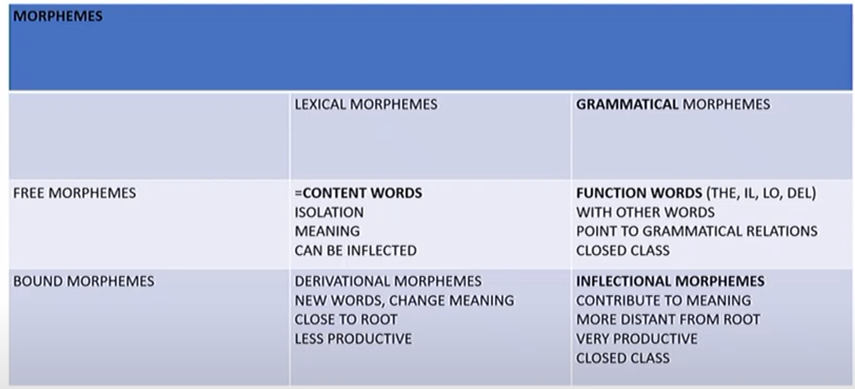
- Content Words: they are lexical morphemes and free morphemes (nouns, verbs, adjectives, adverbs), these can be work in isolation because they have meaning, and they can be inflected. Content words are also called open words because these can be invented.
- Derivational morphemes: they can created new words or change the meaning of words, they are relative productive (but not as much as others morphemes). They are lexical because they have a meaning. These are not closed class because we can’t list, for instance, all the nouns that exist in our language.
- Function Words: these are grammatical morphemes, they are like articles (il, lo, the) and they have to stay with other words. However, they have a meaning in isolation (they don’t have a meaning in themselves but they point to grammatical relations).
- Inflectional Morphemes: these are grammatical morphemes and bound morphemes; they contribute to the meaning, but they are more distant from the root. They are very productive (we use them with all verbs and nouns). As Function Words, they are closed class so we can’t invent new one (for instance, we can’t invent new articles).
Same elements, like articles, can be expressed as Function Words in a language or as Inflectional Morphemes in an other (in Danish articles could be both categories).

Exercise: Find prefixes and suffixes, say the grammatical category of the base form and of the derived form
- Disappointment: - dis (prefix), -ment (suffix), Noun, derived from Verb
- Unemployment: - un (prefix), -ment (suffix), Noun, derived from Verb
- Countless: -less (suffix), Adjective, derived from Verb
- Unfair: - un (prefix), Adjective, derived from Adjective
- Subcategory: - sub (prefix), Noun, derived from Noun
- Foreigner: -er (suffix), Adjective, derived from Noun
- Mispronounce: - mis (prefix), Verb, derived from Verb
- Darkness: -ness (suffix), Adjective, derived from Noun

Exercise: Which are derivational and which inflectional morphemes?
- Arcifelici: -arci (derivational)
- Extralungo: -extra (derivational)
- Ultracontenta: -ultra (derivational)
- Arciinfelici: -arci (derivational), in (derivational)
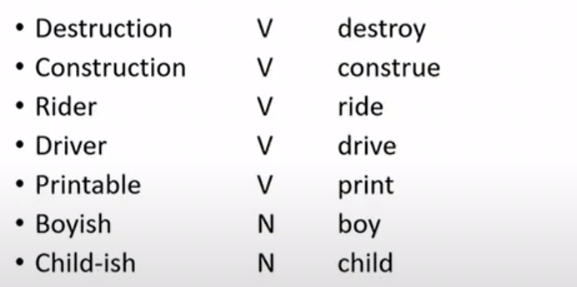
These prefixes are special because they have 2 syllabs

Exercise: Which changes do you see in these words?
- Explore 🡪 Exploration: phonological change (ex’plore 🡪 explo’ration)
- Sane 🡪 Sanity: phonological change (sein 🡪 saeneti)

- Complete 🡪 Incomplete: |
- Logical 🡪 Illogical: |the form of the negative prefix depends on words it attaches to
- Responsible 🡪 Irresponsible: |

Let’s try: There are invent verbs, we have to derive the adjective:
- Pracare (Verb), we try to derive the adjective with suffix -bile: pracabile. We try to construct a finite sentence: Noi prachiamo qualcosa

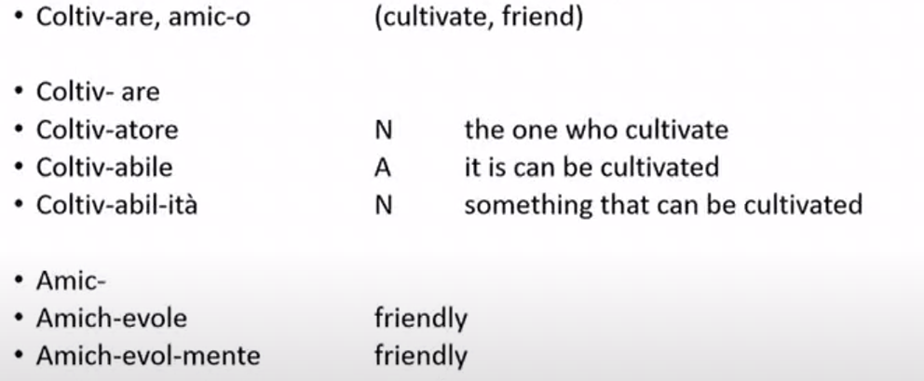
Exercise: We try to build derived words solutions:

Compounding: In a word usually we have one ROOT, but in compounding we can have two. Some examples:
- N + N: Backbone, Barman, Nutshell, Timetable
- A + N: Greenhouse, High-Chair, Smalltalk
- V + N: Cease-fire, Copyright, Showroom
- V + ADV: Lookout, Take off
In some languages, compounding is recursive (like in German, English). For instance, we can form N + N + N like toy – car – crasher (with different structures 🡪 different meanings and different prosodies – pronounce of the first word):
- [[toy car] crasher] 🡪 crasher for toy car
- [toy [car crasher]] 🡪 car crasher which is a toy
Compounding is between morphology and syntax. Ambiguity depends on the way you bracket the words:
- Windmill, coffee table are a type of mill and type of table (table and mill are called head and the other is a modifier)
- Finance committee (head is committee, modifier is Finance)
- [Finance [committee secretary]] (head is secretary)
[Finance [committee [secretary election]]] (head is election)
[Finance [committee [secretary [election scandal]]]] (head is scandal)
In Italian we can’t make this type of sequence compounding.

Noun Incorporation: there is another case in which we have two roots in a word. Some languages instated this type of rule (Oneida, Maya, Maori but not language that we know). This incorporation works by attaching noun into the verb. Basically a word is a sentence.

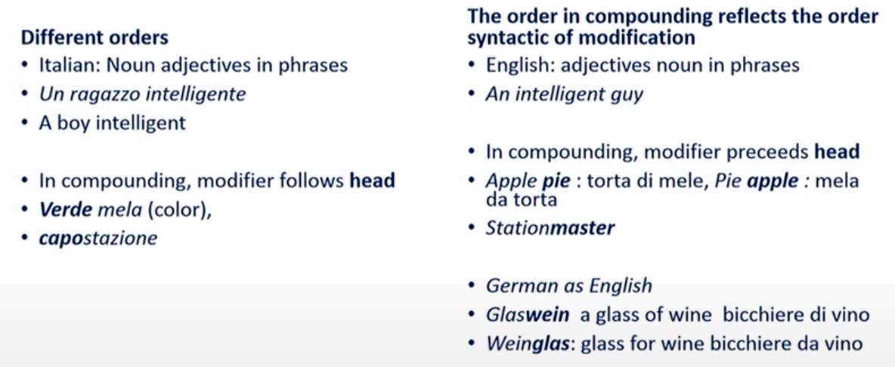
SUMMARY: (with difference between English and Italian)

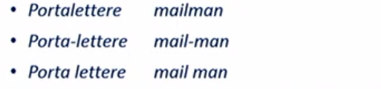
Compound words are sometimes written in a single word and sometimes with a underscore/space. This create confusion, but it completely arbitrary and depends on orthographic decisions.

Exercise: Find the two words that form these compounds. Moreover, which one is the head?
- Sweetcorn
- Dark blue
- Driving License
- Toothpaste
- New York Taxi Driver
- Blackbird
- Breadbasket

MORPHOLOGICAL TYPOLOGY

Measures of morphological typology:
- Index of synthesis: how many morphemes in a word
- Index of fusion: how many morphemes in a morph (-s in speaks encodes two morphemes: PRES and 3SG; -a in tavola encodes two morphemes: FEM and SG) 🡪 how much information you put in a morpheme.

Index of Synthesis: we have two sets of languages:
- Analytical or Isolating: have very little inflectional morphology, generally one word is a morpheme (ex: Mandarin¸ there generally no number, genre, no inflectional nouns, adjectives…)
- Polysynthetic: one word may include more than one root, many morphemes and a word can correspond to a sentence. There is a high use of inflection (African, Iraquoani…).
Index of Fusion:
Synthetic Languages: German, English, Italian use inflectional morphology to mark grammatical categories. There are two dimensions:
- Inflectional: one morpheme encodes more than one piece of information (alber-i, -i indicate PL-MASC; walks, -s PRES-3SG) 🡪 in a single morph we encode more information, between usually 2.5-3 morphemes per word.
- Agglutinative: each morpheme attached to a root expresses a different meaning (Turkish, Japanese), usually between 3-3.5 morphemes per word. Language like Turkish are easily to parse because each morpheme has a different meaning (ex: Dayan-a-m-iyor-um indicate PSB-NEG-IMPF-1SG)

It is useful for a system that does NLP having some information about this 4 types of categories (Analytic, Inflectional, Agglutinative, Polysynthetic)

Indirect index of synthetic without morphological analysis
Given the following intuition:
- English, Italian: we have 4-5 words that we can use in some combinations and the same word can appear more than once in a text (ex: Into his own country)
- Finnish: these words have less chances to appear several times because it is packed into the word (ex: Kotikaupunkiinsa)
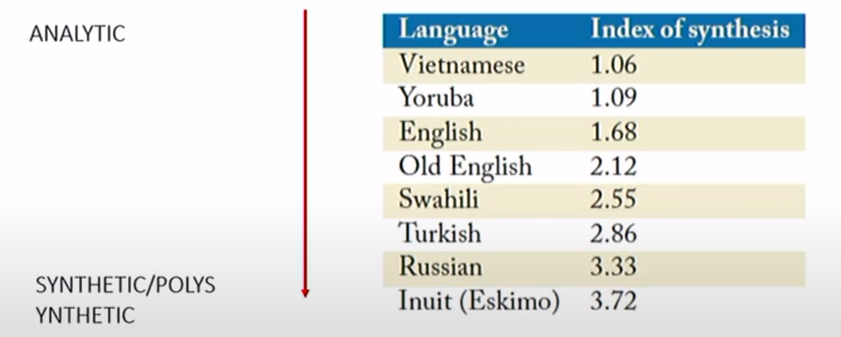
So, it is proposed an indirect index of synthetises without morphological analysis:

English is situated towards the analytic end of the scale, without being one of the outliers. This means that most of the languages are more highly synthetic than English is, and the cross-linguistic portability of NLP systems can in general be improved by anticipating more morphological complexity than is provided by English.
Analytical languages tend to have monomorphic words. Synthetic Languages tend not to have monomorphic words (in Italian there are few monomorphic content words).
We can use this index to analyse in NLP about the new languages that we use. This number lead the system to have expectation about how many morphemes we will encounter, how long a word can be in that language and other.

Particular Morpheme
Sometimes morphemes may consist solely of changes to the tone pattern of a word. Tonal languages associate syllables with relative pitch values and these pitch distinctions can be contrastive, making difference between words (Mandarin, Vietnames, Thai).
A same sequence can have different meaning depending on its pronounce (like principì, princìpi).
There are also null morphemes like cat, cat-s. Detecting null morphemes is important for automatic morphological analysis.

Concatenetive and non-concatenative morphology
- Concatenative: what we have seen until now belongs to this category, so two or more morphemes in order (root 🡪 derivational morphemes 🡪 inflectional morphemes).
- Non-concatenative: all the rest, including change the sound (like German some plural sounds are different from their singular).

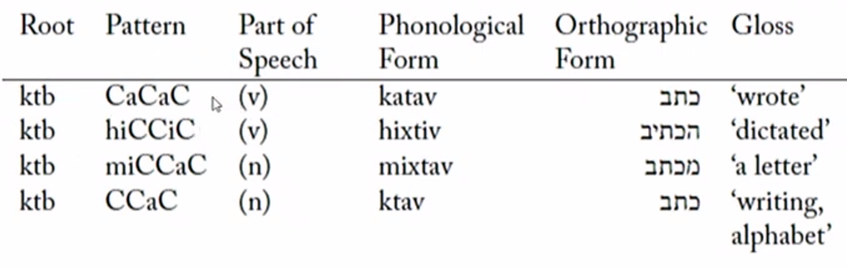
There are cases not in non-concatenative in which the phones making up a morpheme do not have to be contiguous (some Sematic or Arabic languages are examples):

TOKENIZATION
First process that we have to make when we approach to a text is Tokenization. This process is an algorithm that divides text into individual components, inserting spaces and separating punctuation marks. Finding tokens in languages like Italian, English is easy because there are spaces, but languages like Mandarin have not spaces so this process becomes more difficult.
In some cases, it is difficult to understand whether some words are formed by one or two tokens (ex: I did not, I didn’t)

LEMMATIZATION
It is the process that find the lemma of a word based on which part of the speech it is. Ex:
- The storm will bring high winds and rain 🡪 Here the lemma is storm that is a NOUN.
- It will storm all night before the hurricane passes 🡪 Here the lemma is to storm that is a VERB

CORPORA
Morphology offers a theoretical framework and set of concepts useful for analysing a corpus (a set of text today digitalized).
When we have a corpus, we have to tokenize it, check structure of words, establish which words are complexes.
Corpora can be specialized for a certain register (= variety of language used in certain contexts like family, school, formal contexts) 🡪 language spoken at home or school, difference between written and spoken, honorific use like tu (informal) or lei (formal)
Corpora can be enriched with information through language databases that are annotated semi-automatically and controlled by human experts (annotation means indicating the part of speech).
Some databases tools for working with texts:
- CELEX: provides morphological analysis of words in English, German, Dutch, but it is limited in size and contains more errors.
- WordNet: large language databases with nouns, adjectives, words in general in English. It gives us some information about the words we are searching.
- Morph-it!: databases for Italian language.
These systems are called:
- Stemmer: a system that identifies complex words that are already by removing affixes from a word (affix stripping). The stem is the root (or similar). What it finds is not necessarily a word: Cant-(avo, are); Sing. Sometimes the stem could coincise with the lemma (ex: sing), other times it does not coincide (ex: cant🡪 stem, cantare🡪lemma). For a stemmer to find the relationship is impossible because there are no morphemes in common.
- Lemmatizer: identifies complex words that are related and identifies the lemma or basic form (which is always a word). It needs a dictionary and grammatical categories (N,V,A). Ex: Bring, Brought have the same lemma 🡪 bring.
Both systems that find lemma and stem works well for inflectional morphology that because it is predictable (in Italian every nouns end with a morpheme that conveys with a genre, number; every verb end with a morpheme that conveys person, genre…) ; derivational morphology is less predictable.

There are two types of automatic systems that can do morphological analysis on texts based on rules:
- The rules that enter in the system for Italian are not the same for the English
- There are analysis systems that are based on observed regularities in sequence. They observe and compare words (if for instance the word able is present more times in a text, this word is good a candidate to be a morpheme 🡪 inducing morphemes are based on frequency information).

Tinkful: is a visualization and annotation based on Tint, a Java-based pipeline for NLP in Italian. It allows to visualize, annotate and correct most common linguistic tasks such as part-of-speech tagging, dependency parsing, entity linking (dh.fbk.eu/tint-demo/).

WHAT WE KNOW UNTIL NOW:
- Token, Tokenization
- Lemma, Lemmatization
- Stemmer

- Morph can instantiate one or more morphemes
- Grammatical morphology: Inflectional morphology, Function words
- Derivational morphology
- Compounding

- Root
- Stem
- Base form, Lemma, Lexeme

